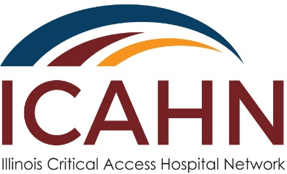

January 4, 2021

TO: All SHIP Grant Applicants

FROM: Brian Ashpole, Grant Project Coordinator/ICAHN

SUBJECT: FY21 (2021-2022) SHIP Grant Application – Due January 22nd, 2021

The FY21 (2021-2022) SHIP Grant Hospital Application is attached in the associated email and will also be available online at www.icahn.org. The 2021-2022 SHIP Grant period runs from June 1, 2021 – May 31, 2022.You may request a maximum of $11,855.00 for your grant project. The application deadline is Friday, January 22nd, 2021. Please send completed applications to Brian Ashpole (bashpole@icahn.org).

The SHIP Purchasing Menu is broken into three main categories, which are as follows:
- Value-Based Purchasing (VBP) Investment Activities
- Accountable Care Organization (ACO) or Shared Savings Investment Activities
- Payment Bundling (PB) or Prospective Payment System (PPS) Investment Activities

There is also the option to join a Special Innovations Project (SIP). The SIPs are group projects where at least 3 hospitals pool all their grant funds for the next two project years (FY21 and FY22). There are six potential projects to choose from on the application.

An informational webinar will be held on Thursday January 6th, 2021 at 3:00 PM to review the 2021-2022 SHIP Grant. The webinar will be recorded, in case you are unable to attend. You can access the webinar using this link: https://icahn-org.zoom.us/j/97580814909

The SHIP Grant is supported by the U.S. Department of Health and Human Services, Health Resources and Services Administration’s Federal Office of Rural Health Policy (FORHP),and is made available to us through the Illinois Department of Public Health’s (IDPH) Center for Rural Health. IDPH is State Office of Rural Health (SORH) and officially submits the SHIP Grant application and reports to FORHP. ICAHN manages the SHIP Grant program on behalf of SORH.

If you have any questions or concerns, please send an email to bashpole@icahn.org, or call the ICAHN office at (815)875-2999.

