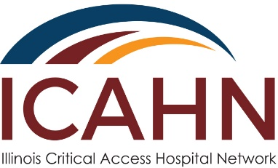

EMS Education Award
2019-2020
Application Form

Award Description
The Emergency Medical Services (EMS) Education Award is available to all Illinois critical access hospitals. The intent of this award is to provide funding for hospital EMS to conduct local EMS education programs and assist local units with updates on billing practices or leadership development, including EMS Needs Assessment.

Award Project Suggestions:
- EMT Continuing Education
- EMS Safety Training
- Advanced Training Courses
- Training Manikins
- American Heart Association Trainings
- Physician Programs on Cardiac Care
- EMS Community Awareness
- 1st Responder Training
- Needs Assessment Survey
- Education Programs from STEMI Centers

Note - Cannot be used for capital equipment.

Project Period: September 1, 2019 – June 30, 2020

Amount: $3,000 maximum for each recipient. There are approximately 15 awards available.

Application Deadline: December 6, 2019

Contact: Brian Ashpole, Data and Grant Project Coordinator
Illinois Critical Access Hospital Network
1945 Van’s Way
Princeton, IL 61356
Phone: (815) 875-2999
bashpole@icahn.org

Application Instructions
All application fields/sections must be completed. Applications with blank fields/sections will be considered non-responsive and will not be considered for award. Applicants must be in compliance with all previous awards in order to be eligible. Only one application per hospital per category will be accepted.

Please send completed application to the above address no later than Friday, December 6, 2019. Applications may also be sent electronically to Brian Ashpole bashpole@icahn.org. The application can be accessed electronically at www.icahn.org. Applications are to be submitted in a word processing format or PDF. Handwritten applications are no longer accepted. Fields may be expanded to suit the space requirements of the response; however, all fields must be included, i.e., do not delete any fields or fail to respond to information sought in each field.

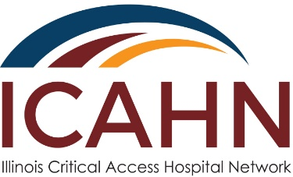

EMS Education Award
2019-2020
Application Form

Due back to the Illinois Critical Access Hospital Network by December 6, 2019

Hospital Name | Date
Address | Contact Person
Phone Number | Email Address
FEIN (Federal Employee Identification Number) | IDHR # (Illinois Department of Human Rights)
*Blank fields may result in application being considered non-responsive.

Hospital Ownership (please mark one):

[ ] For Profit; [ ] Not for Profit; [ ] Government

Authorized Signature: _________________________________________________________________

PROGRAM NARRATIVE
Please respond to each question. Question fields left blank will result in application being considered non-responsive. Each question area should be expanded so sufficient detail can be provided. Additional pages may be attached as necessary.

- What do you plan to use the funds for? Please check one (1) or more areas this award program/project will address:

☐ EMT Continuing Education
☐ EMS Safety Training
☐ Advanced Training Courses
☐ Training Manikins
☐ American Heart Association Trainings
☐ Physician Programs on Cardiac Care
☐ EMS Community Awareness
☐ 1st Responder Training
☐ Needs Assessment Survey
☐ Education Programs from STEMI Centers
☐ Other______________________

2. Describe the proposed program/project and the impact this project will have to strengthen existing services, improve operations, or add new services to the facility. Describe your local EMS community.

3. Describe your hospital’s current efforts in the identified program/project and how successful it has been.

4. Define the problem or issue you would like to address and how it relates to the overall goal of the award. What is not being accomplished and why is it not being accomplished?

5. Identify the desired outcomes you would like to achieve (example: train certain number of participants).

Short term outcomes (less than 6 months) | Long term outcomes (6 months or greater)
1. | 1.
2. | 2.
3. | 3.
How will these outcomes be achieved and how will they affect your EMS community?

6. Describe the planning process, education and implementation timetable for this program/project. (Who is involved and who is responsible for the project?)

7. How will the program/project improve the overall operations of EMS, the hospital, and the community? Identify factors (external/environmental) that may impact your outcomes, including sustainability.

8. Describe the level of local commitment and the extent to which the project will contribute to your community.

9. Describe how you will measure/evaluate the value and effectiveness of the program/project (examples: pre-test and post-test, participant listings for educational programs).

Measure 1
Measure 2
Measure 3
Measure 4

What indicators will be used to evaluate the program/project and what milestones have you identified as being important?

2019-2020 Proposed Award Budget
Category | Award Funds | Matching Funds | Total Funds
Consultant’s Fees
Contracted Services
Communications/Marketing
Education/Training
Equipment/Supplies
Hardware/Software
Total

Budget Narrative Provide detail of the amounts listed in budget section above. You may include additional materials to further support this Award Application. If documentation is not provided to explain expenses listed in each category your application will not be eligible for an award. Include consultant qualifications and level of expertise for the project. Please only include allowable expenses as identified in the state cost principles as part of uniform guidance.

Consultant’s Fees

Contracted Services

Communications/Marketing

Education/Training

Equipment/Supplies

Hardware/Software

Review Criteria – Application Hints
This Award Application will be reviewed by outside award reviewers and assigned awarding scores based on the following criteria:

1. Was all hospital information completed (including Federal Employee Identification Number, Illinois Department of Human Rights Number, and Hospital Ownership)?
2. How well did the applicant explain the problem/issue and how they were planning on addressing it?
3. Is the program/project clearly described?
4. Is information provided which supports the idea that the program/project will meet the identified outcomes?
5. Is the method of evaluating the effectiveness of the program/project reasonable?
6. Does the applicant provide enough budgetary detail to assess the likely success of the program/project?
7. Is the budget reasonable for this type of program/project?
8. Is there an indication that this program/project will continue in the future?
9. Does the program/project make sense? Is it valuable to the community? Does it improve the hospital? Is there community involvement?

